**JAWABAN KUIS MYSQL**

1. [**SELECT**](http://localhost:8080/phpmyadmin/url.php?url=https://dev.mysql.com/doc/refman/8.0/en/select.html) **\* FROM anggotas JOIN users ON users.id_anggota = anggotas.id;**



1. [**SELECT**](http://localhost:8080/phpmyadmin/url.php?url=https://dev.mysql.com/doc/refman/8.0/en/select.html) **\* FROM anggotas WHERE** [**NOT**](http://localhost:8080/phpmyadmin/url.php?url=https://dev.mysql.com/doc/refman/8.0/en/logical-operators.html#operator_not) **EXISTS (**[**SELECT**](http://localhost:8080/phpmyadmin/url.php?url=https://dev.mysql.com/doc/refman/8.0/en/select.html) **id FROM users WHERE users.id_anggota = anggotas.id);**

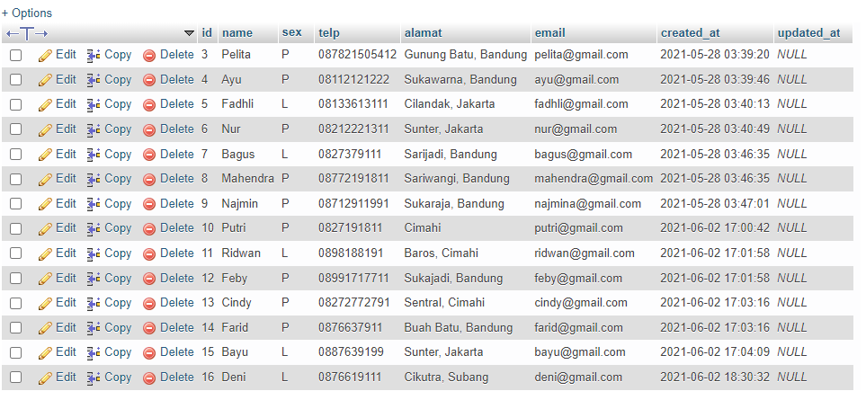

1. [**SELECT**](http://localhost:8080/phpmyadmin/url.php?url=https://dev.mysql.com/doc/refman/8.0/en/select.html) **\* FROM anggotas** [**LEFT**](http://localhost:8080/phpmyadmin/url.php?url=https://dev.mysql.com/doc/refman/8.0/en/string-functions.html#function_left) **JOIN peminjaman ON peminjaman.id_anggota = anggotas.id WHERE** [**NOT**](http://localhost:8080/phpmyadmin/url.php?url=https://dev.mysql.com/doc/refman/8.0/en/logical-operators.html#operator_not) **EXISTS (**[**SELECT**](http://localhost:8080/phpmyadmin/url.php?url=https://dev.mysql.com/doc/refman/8.0/en/select.html) **id FROM peminjaman WHERE peminjaman.id_anggota = anggotas.id );**

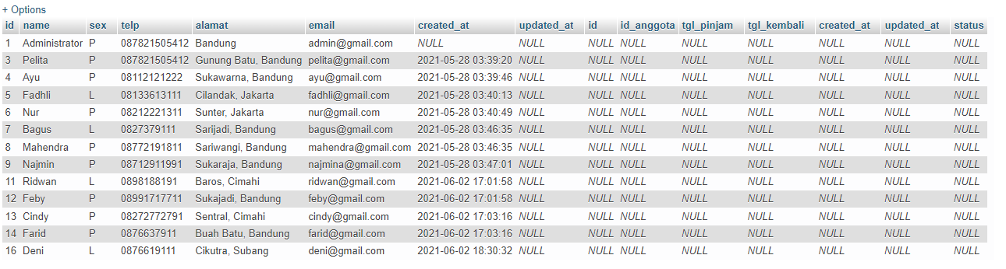

1. [**SELECT**](http://localhost:8080/phpmyadmin/url.php?url=https://dev.mysql.com/doc/refman/8.0/en/select.html) **anggotas.id, anggotas.name, anggotas.telp FROM anggotas** [**RIGHT**](http://localhost:8080/phpmyadmin/url.php?url=https://dev.mysql.com/doc/refman/8.0/en/string-functions.html#function_right) **JOIN peminjaman ON peminjaman.id_anggota = anggotas.id;**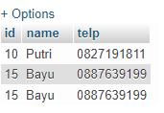
2. [**SELECT**](http://localhost:8080/phpmyadmin/url.php?url=https://dev.mysql.com/doc/refman/8.0/en/select.html) **anggotas.id, anggotas.name, anggotas.telp**

**FROM anggotas** [**RIGHT**](http://localhost:8080/phpmyadmin/url.php?url=https://dev.mysql.com/doc/refman/8.0/en/string-functions.html#function_right) **JOIN peminjaman ON peminjaman.id_anggota = anggotas.id JOIN detail_peminjaman ON detail_peminjaman.id_peminjaman = peminjaman.id**

**GROUP BY name**

**HAVING** [**SUM**](http://localhost:8080/phpmyadmin/url.php?url=https://dev.mysql.com/doc/refman/8.0/en/group-by-functions.html#function_sum)**(detail_peminjaman.qty) > 1;**

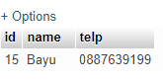

1. **SELECT anggotas.name, anggotas.telp, anggotas.alamat, peminjaman.tgl_pinjam, peminjaman.tgl_kembali**

**FROM anggotas**

**RIGHT JOIN peminjaman ON peminjaman.id_anggota = anggotas.id;**

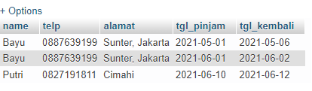

1. **SELECT anggotas.name, anggotas.telp, anggotas.alamat, peminjaman.tgl_pinjam, peminjaman.tgl_kembali**

**FROM anggotas**

**RIGHT JOIN peminjaman ON peminjaman.id_anggota = anggotas.id**

**WHERE peminjaman.tgl_kembali LIKE '%2021-06%';**

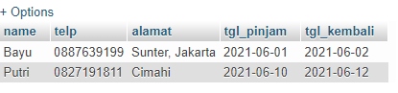

1. [**SELECT**](http://localhost:8080/phpmyadmin/url.php?url=https://dev.mysql.com/doc/refman/8.0/en/select.html) **anggotas.name, anggotas.telp, anggotas.alamat, peminjaman.tgl_pinjam, peminjaman.tgl_kembali FROM anggotas** [**RIGHT**](http://localhost:8080/phpmyadmin/url.php?url=https://dev.mysql.com/doc/refman/8.0/en/string-functions.html#function_right) **JOIN peminjaman ON peminjaman.id_anggota = anggotas.id WHERE peminjaman.tgl_pinjam** [**LIKE**](http://localhost:8080/phpmyadmin/url.php?url=https://dev.mysql.com/doc/refman/8.0/en/string-comparison-functions.html#operator_like) **'%2021-05%';**

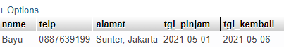

1. [**SELECT**](http://localhost:8080/phpmyadmin/url.php?url=https://dev.mysql.com/doc/refman/8.0/en/select.html) **anggotas.name, anggotas.telp, anggotas.alamat, peminjaman.tgl_pinjam, peminjaman.tgl_kembali FROM anggotas** [**RIGHT**](http://localhost:8080/phpmyadmin/url.php?url=https://dev.mysql.com/doc/refman/8.0/en/string-functions.html#function_right) **JOIN peminjaman ON peminjaman.id_anggota = anggotas.id WHERE peminjaman.tgl_kembali** [**LIKE**](http://localhost:8080/phpmyadmin/url.php?url=https://dev.mysql.com/doc/refman/8.0/en/string-comparison-functions.html#operator_like) **'%2021-06%'** [**AND**](http://localhost:8080/phpmyadmin/url.php?url=https://dev.mysql.com/doc/refman/8.0/en/logical-operators.html#operator_and) **peminjaman.tgl_kembali** [**LIKE**](http://localhost:8080/phpmyadmin/url.php?url=https://dev.mysql.com/doc/refman/8.0/en/string-comparison-functions.html#operator_like) **'%2021-06%';**

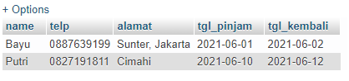

1. [**SELECT**](http://localhost:8080/phpmyadmin/url.php?url=https://dev.mysql.com/doc/refman/8.0/en/select.html) **anggotas.name, anggotas.telp, anggotas.alamat, peminjaman.tgl_pinjam, peminjaman.tgl_kembali FROM anggotas** [**LEFT**](http://localhost:8080/phpmyadmin/url.php?url=https://dev.mysql.com/doc/refman/8.0/en/string-functions.html#function_left) **JOIN peminjaman ON peminjaman.id_anggota = anggotas.id WHERE anggotas.alamat** [**LIKE**](http://localhost:8080/phpmyadmin/url.php?url=https://dev.mysql.com/doc/refman/8.0/en/string-comparison-functions.html#operator_like) **'%Bandung%';**

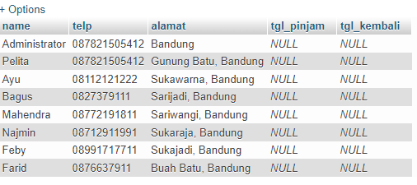

1. [**SELECT**](http://localhost:8080/phpmyadmin/url.php?url=https://dev.mysql.com/doc/refman/8.0/en/select.html) **anggotas.name, anggotas.telp, anggotas.alamat, peminjaman.tgl_pinjam, peminjaman.tgl_kembali FROM anggotas** [**LEFT**](http://localhost:8080/phpmyadmin/url.php?url=https://dev.mysql.com/doc/refman/8.0/en/string-functions.html#function_left) **JOIN peminjaman ON peminjaman.id_anggota = anggotas.id WHERE anggotas.alamat** [**LIKE**](http://localhost:8080/phpmyadmin/url.php?url=https://dev.mysql.com/doc/refman/8.0/en/string-comparison-functions.html#operator_like) **'%Bandung%'** [**AND**](http://localhost:8080/phpmyadmin/url.php?url=https://dev.mysql.com/doc/refman/8.0/en/logical-operators.html#operator_and) **anggotas.sex = "P";**

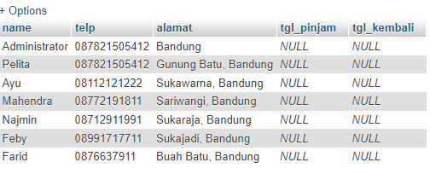

1. [**SELECT**](http://localhost:8080/phpmyadmin/url.php?url=https://dev.mysql.com/doc/refman/8.0/en/select.html) **anggotas.name, anggotas.telp, anggotas.alamat, peminjaman.tgl_pinjam, peminjaman.tgl_kembali, bukus.isbn, detail_peminjaman.qty FROM anggotas** [**LEFT**](http://localhost:8080/phpmyadmin/url.php?url=https://dev.mysql.com/doc/refman/8.0/en/string-functions.html#function_left) **JOIN peminjaman ON peminjaman.id_anggota = anggotas.id** [**LEFT**](http://localhost:8080/phpmyadmin/url.php?url=https://dev.mysql.com/doc/refman/8.0/en/string-functions.html#function_left) **JOIN detail_peminjaman ON detail_peminjaman.id_peminjaman = peminjaman.id** [**LEFT**](http://localhost:8080/phpmyadmin/url.php?url=https://dev.mysql.com/doc/refman/8.0/en/string-functions.html#function_left) **JOIN bukus ON bukus.id = detail_peminjaman.id_buku WHERE detail_peminjaman.qty > 1;**

**Kosong**

1. [**SELECT**](http://localhost:8080/phpmyadmin/url.php?url=https://dev.mysql.com/doc/refman/8.0/en/select.html) **anggotas.name, anggotas.telp, anggotas.alamat, peminjaman.tgl_pinjam, peminjaman.tgl_kembali, bukus.isbn, detail_peminjaman.qty, bukus.judul, bukus.harga_pinjam, detail_peminjaman.qty * bukus.harga_pinjam AS Total**

**FROM anggotas**

**JOIN peminjaman ON peminjaman.id_anggota = anggotas.id**

[**LEFT**](http://localhost:8080/phpmyadmin/url.php?url=https://dev.mysql.com/doc/refman/8.0/en/string-functions.html#function_left) **JOIN detail_peminjaman ON detail_peminjaman.id_peminjaman = peminjaman.id**

[**LEFT**](http://localhost:8080/phpmyadmin/url.php?url=https://dev.mysql.com/doc/refman/8.0/en/string-functions.html#function_left) **JOIN bukus ON bukus.id = detail_peminjaman.id_buku;**

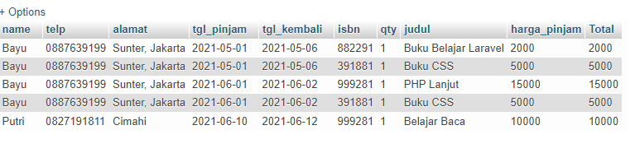

1. [**SELECT**](http://localhost:8080/phpmyadmin/url.php?url=https://dev.mysql.com/doc/refman/8.0/en/select.html) **anggotas.name, anggotas.telp, anggotas.alamat, peminjaman.tgl_pinjam, peminjaman.tgl_kembali, bukus.isbn, detail_peminjaman.qty, bukus.judul, bukus.harga_pinjam, pengarangs.nama_pengarang, penerbits.nama_penerbit, katalogs.nama FROM anggotas** [**LEFT**](http://localhost:8080/phpmyadmin/url.php?url=https://dev.mysql.com/doc/refman/8.0/en/string-functions.html#function_left) **JOIN peminjaman ON peminjaman.id_anggota = anggotas.id** [**LEFT**](http://localhost:8080/phpmyadmin/url.php?url=https://dev.mysql.com/doc/refman/8.0/en/string-functions.html#function_left) **JOIN detail_peminjaman ON detail_peminjaman.id_peminjaman = peminjaman.id** [**LEFT**](http://localhost:8080/phpmyadmin/url.php?url=https://dev.mysql.com/doc/refman/8.0/en/string-functions.html#function_left) **JOIN bukus ON bukus.id = detail_peminjaman.id_buku JOIN pengarangs ON pengarangs.id = bukus.id_pengarang JOIN penerbits ON penerbits.id = bukus.id_penerbit JOIN katalogs ON katalogs.id = bukus.id_katalog;**

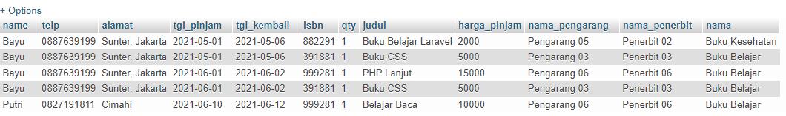

1. [**SELECT**](http://localhost:8080/phpmyadmin/url.php?url=https://dev.mysql.com/doc/refman/8.0/en/select.html) **katalogs.id, katalogs.nama, katalogs.created_at, katalogs.updated_at, bukus.judul FROM katalogs JOIN bukus ON bukus.id_katalog = katalogs.id;**

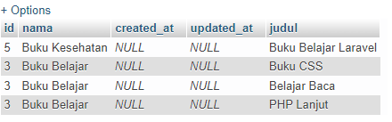

1. [**SELECT**](http://localhost:8080/phpmyadmin/url.php?url=https://dev.mysql.com/doc/refman/8.0/en/select.html) **bukus.id, bukus.isbn, bukus.judul, bukus.tahun, bukus.id_penerbit, bukus.id_pengarang, bukus.id_katalog, bukus.qty_stok, bukus.qty_stok, bukus.harga_pinjam , bukus.created_at, bukus.updated_at, penerbits.nama_penerbit FROM bukus** [**LEFT**](http://localhost:8080/phpmyadmin/url.php?url=https://dev.mysql.com/doc/refman/8.0/en/string-functions.html#function_left) **JOIN penerbits ON penerbits.id = bukus.id_penerbit;**

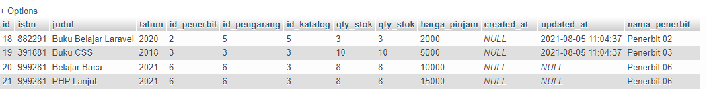

1. [**SELECT**](http://localhost:8080/phpmyadmin/url.php?url=https://dev.mysql.com/doc/refman/8.0/en/select.html) **bukus.id, bukus.isbn, bukus.judul, bukus.tahun, bukus.id_pengarang, bukus.qty_stok, pengarangs.nama_pengarang FROM bukus JOIN pengarangs ON pengarangs.id = bukus.id_pengarang WHERE pengarangs.nama_pengarang = "Pengarang 05";**

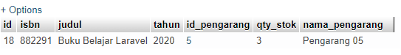

1. [**SELECT**](http://localhost:8080/phpmyadmin/url.php?url=https://dev.mysql.com/doc/refman/8.0/en/select.html) **\* FROM `bukus` WHERE bukus.harga_pinjam > 10000;**



1. [**SELECT**](http://localhost:8080/phpmyadmin/url.php?url=https://dev.mysql.com/doc/refman/8.0/en/select.html) **bukus.id, bukus.isbn, bukus.judul, bukus.tahun, bukus.id_penerbit, bukus.id_pengarang, bukus.id_katalog, bukus.qty_stok, bukus.harga_pinjam, penerbits.nama_penerbit FROM bukus JOIN penerbits ON penerbits.id = bukus.id_penerbit WHERE penerbits.nama_penerbit = "Penerbit 01"** [**AND**](http://localhost:8080/phpmyadmin/url.php?url=https://dev.mysql.com/doc/refman/8.0/en/logical-operators.html#operator_and) **bukus.qty_stok > 10;**

**Kosong**

1. [**SELECT**](http://localhost:8080/phpmyadmin/url.php?url=https://dev.mysql.com/doc/refman/8.0/en/select.html) **\* FROM `anggotas` WHERE anggotas.created_at** [**LIKE**](http://localhost:8080/phpmyadmin/url.php?url=https://dev.mysql.com/doc/refman/8.0/en/string-comparison-functions.html#operator_like) **'%2021-06%';**

